|  |
| --- |
|  |
| ***KUMASI MARKET***  *Web Application User’s Manual* |
| |  |  |  | | --- | --- | --- | | **BY: softmasters** |  |  | |

**TABLE OF CONTENTS**

CHAPTER ONE 1

LOGIN 1

CHAPTER TWO 2

GETTING STARTED 2

GENERAL USER INTERFACE 2

1. Master Register 2

2. New Registration 2

3. User Management and Administration 2

4. Customer Relations Management 2

5. Payments, Invoicing and Banking 2

6. Revenue Management 2

7. Asset Management 2

8. Reports and statistics 2

9. Quick Menu 2

CHAPTER THREE 3

REGISTRATION 3

Individual Registration 3

Business Registration 4

Change Password 4

CHAPTER FOUR 5

STORE ALLOCATION 5

New Store Allocation 5

Change store Allocation 7

Multiple Allocation 7

Adding Affiliates 7

CHAPTER FIVE 9

ASSET MANAGEMENT 9

Asset Manager Dashboard 9

1. Asset Allocation 9

2. Setting and Configuration 10

3. Add Asset/Property 10

4. Asset Listing/Registration 11

# **CHAPTER ONE**

# **LOGIN**

Access the application using [http://kma.ucomgh.com](http://kma.ucomgh.com/). The website immediately displays the login screen which authenticates a user.

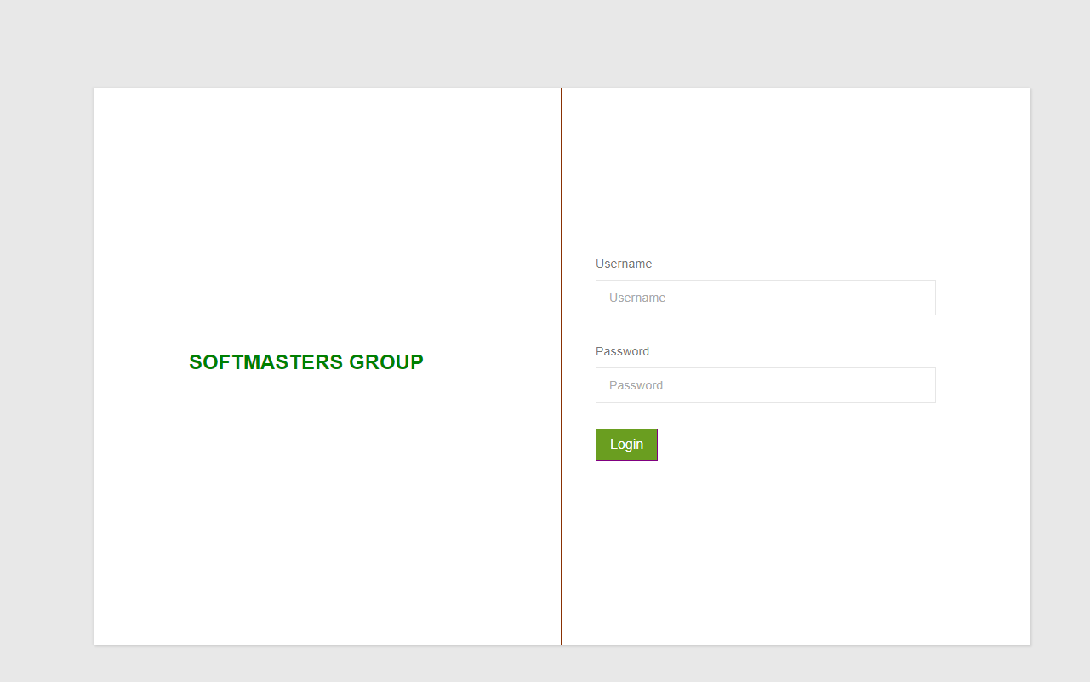

***Login Screen***

Type email address in (1) and password in (2). Click on (3) to login or press < Enter > on the keyboard to authenticate credentials.

# **CHAPTER TWO**

# **GETTING STARTED**

## **GENERAL USER INTERFACE**

Once logged in the website displays the administrator dashboard with all its functionalities. 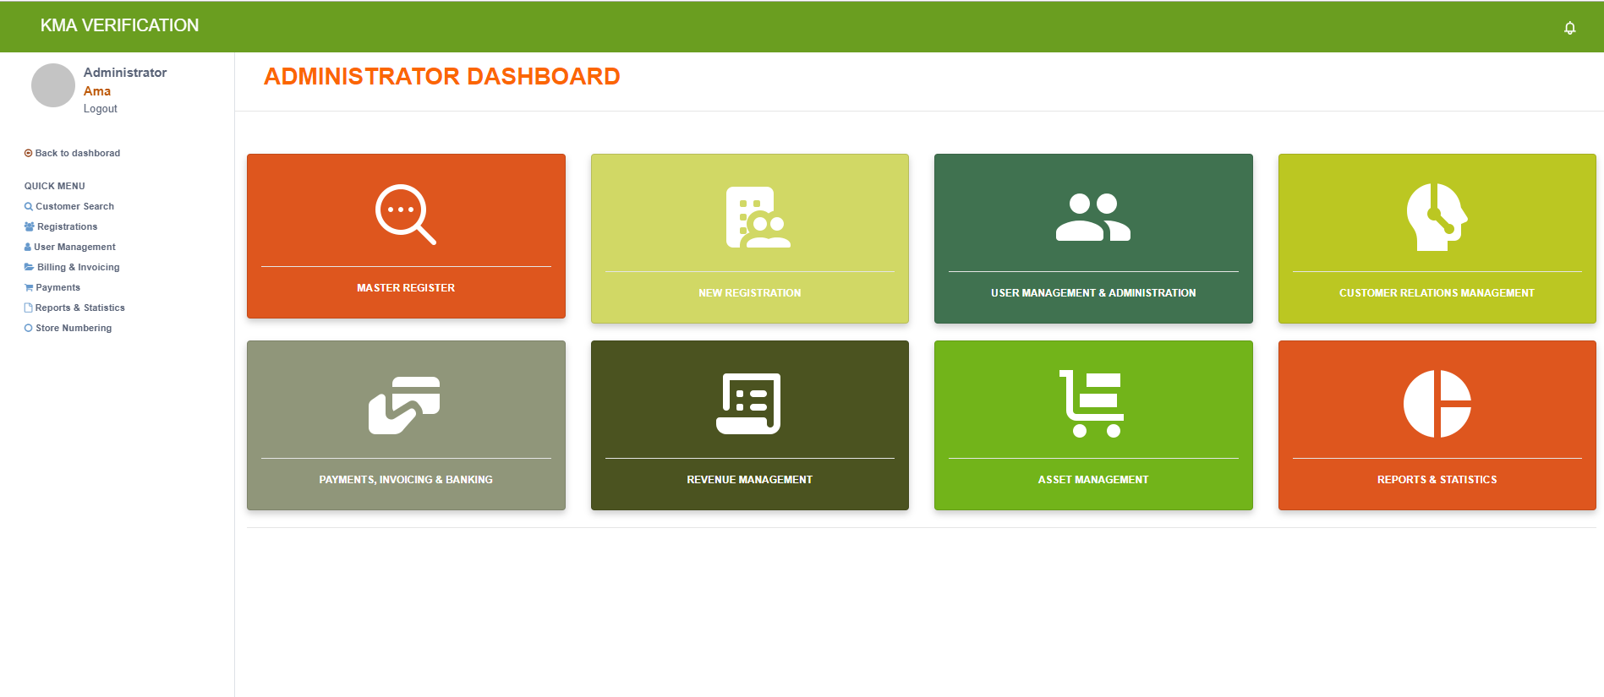

***Administrator Dashboard***

### **Master Register**

Use this widget to access the summary of data collected and search for a trader using name or telephone number.

### **New Registration**

Register entities for a new account.

### **User Management and Administration**

### **Customer Relations Management**

### **Payments, Invoicing and Banking**

### **Revenue Management**

### **Asset Management**

Allows for registration of new products, properties or assets with enough information for allocation, maintenance, identification and accountability.



### **Reports and statistics**

Generates a breakdown of data collected for each phase of the market with the overall number of stores.

### **Quick Menu**

Provides a list of functionalities on the dashboard and is seen on every page for easy access to items on the dashboard.

# **CHAPTER THREE**

# **REGISTRATION**

## **Individual Registration**

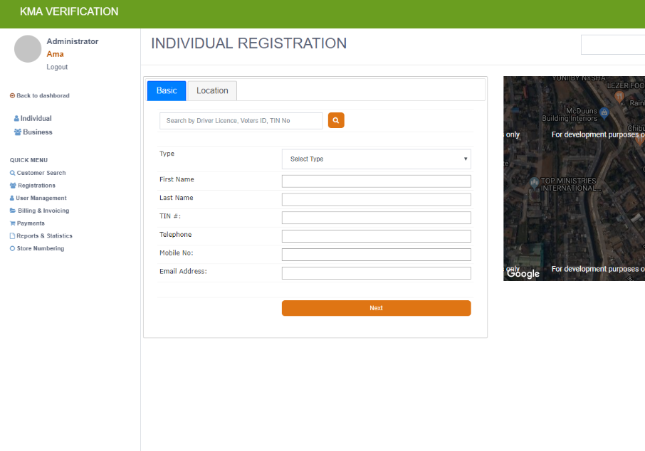Click the new registration on the dashboard or register on the quick menu to begin.

1. Type in all the fields on the basic tab (1)
2. Click on (2) or (3) to continue.
3. Fields on the next page can be filled automatically by typing the location in the search box (4).

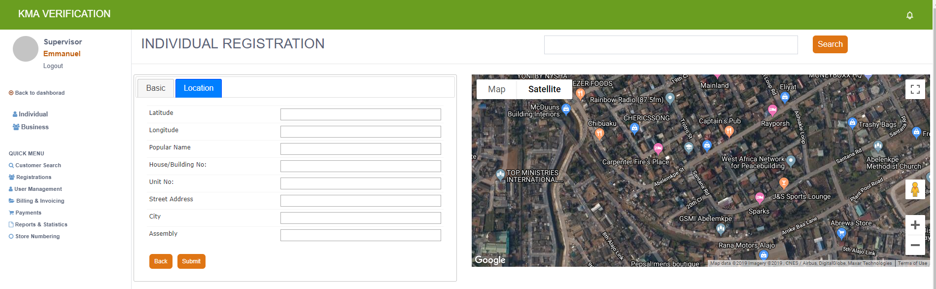 Otherwise, fill in the fields manually.

1. Click on submit (5) to save the basic information.
2. In the quick menu, click on ***User Management.***
3. Click configure user (6), at the left of the table displayed, for the account you want to configure.
4. On the edit account type in a password (7) and confirm (8)

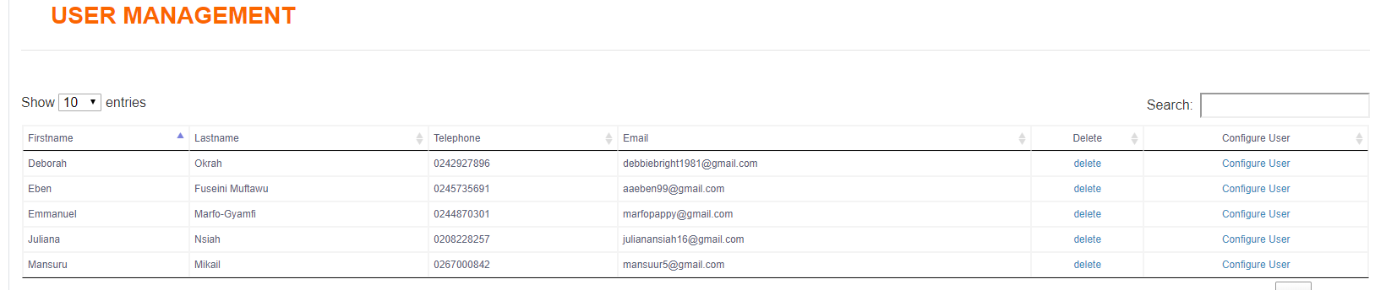On the right side of the page, click (9) and select a role. Click on Add role button (10) and then submit (11) to complete the process.

***Notice the notification after submission.***

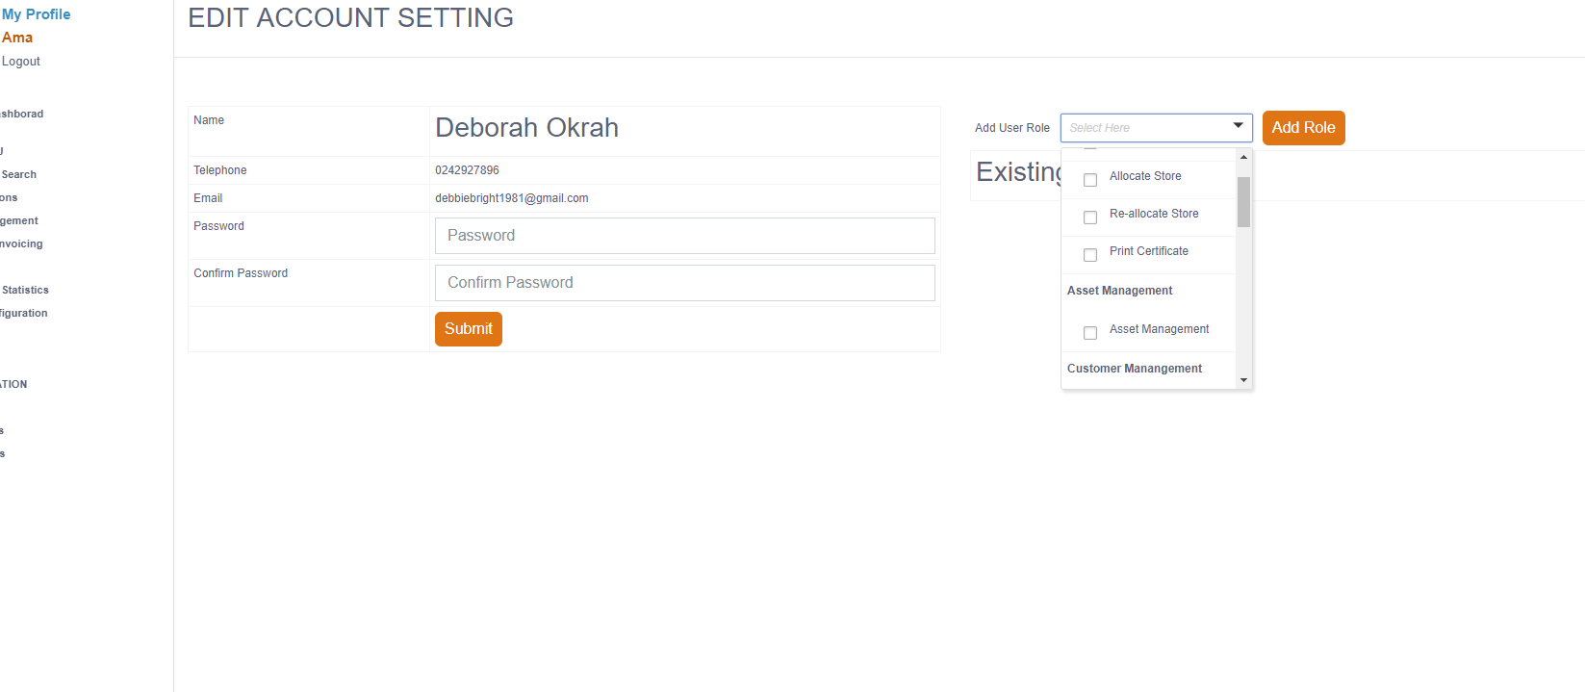***Edit Account Setting Page***

## **Business Registration**

Repeat steps as in the individual registration with two added tabs. Fill out the tabs accordingly and submit to create an account for a company/business.

## 

## **Change Password**

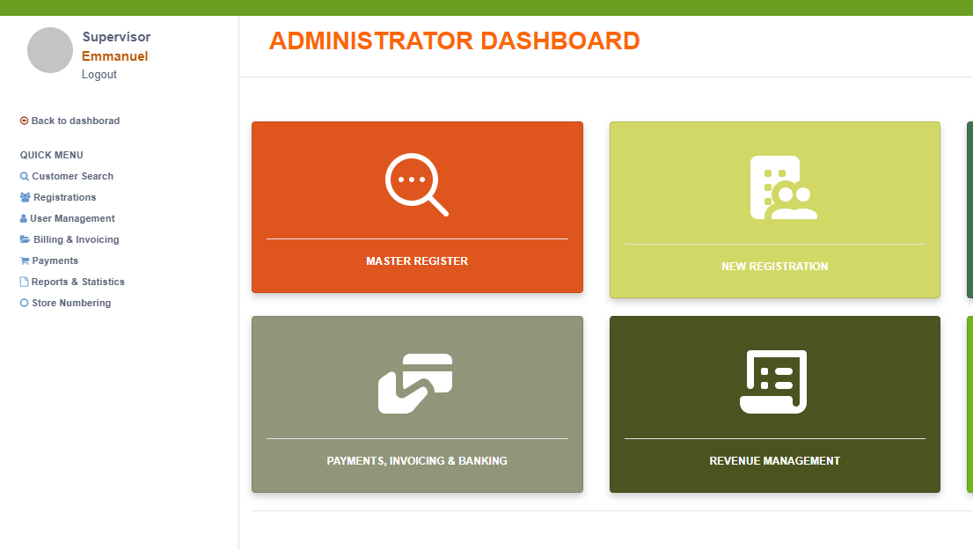The new user *(****i.e. individual/business****)* can change the password given during the new account registration by doing the following:

1. Click on the ash circle (1)

close at the left side of the home page.

1. On the resulting page (edit profile settings).
2. Enter your new password (2) and confirm the new password (3)
3. Click on the change password button (4) to set new password.

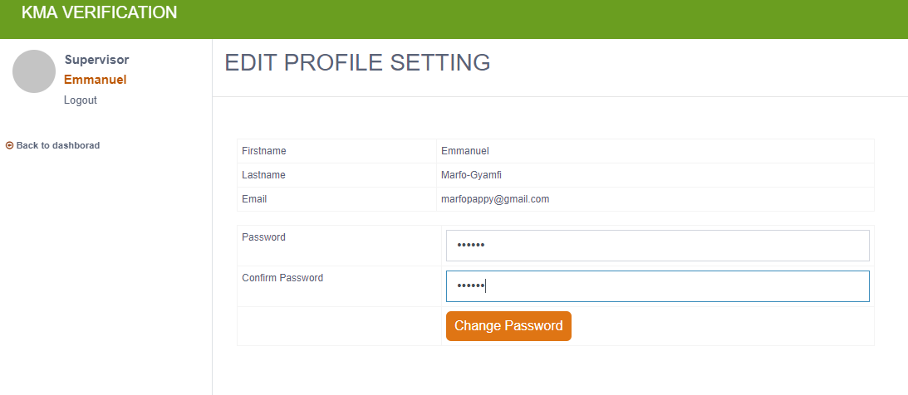

# **CHAPTER FOUR**

# **STORE ALLOCATION**

## **New Store Allocation**

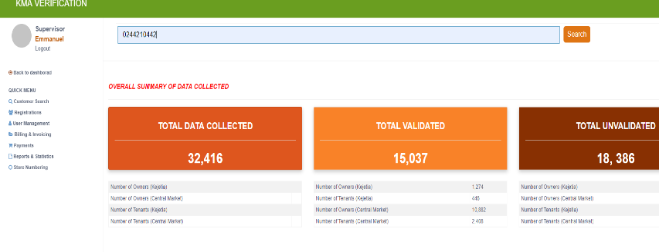Click on the master register widget or the customer register in the Quick Menu.

1. Type in the trader’s name or the telephone in the search box and click on search (1) or press <Enter>.
2. On the table displayed click on the name.
3. A validation record page is opened. Click on (2) and the okay on the pop-up screen to continue.
4. 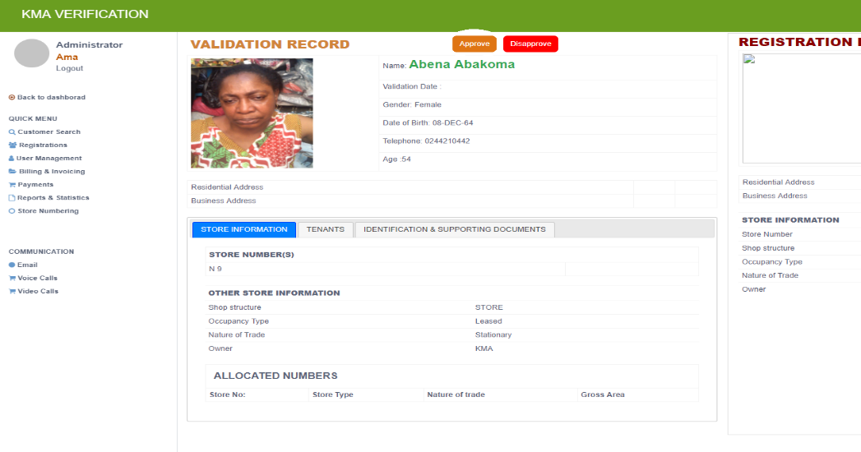 Click on the proceed to allocate button (3) on the pop-up screen.

Depending on the nature of trade displayed in store information, select the floor with the particular trade.

Based on traders preferred store number, check to see if shop has already been allocated. If not, proceed to allocating the preferred store to the user.

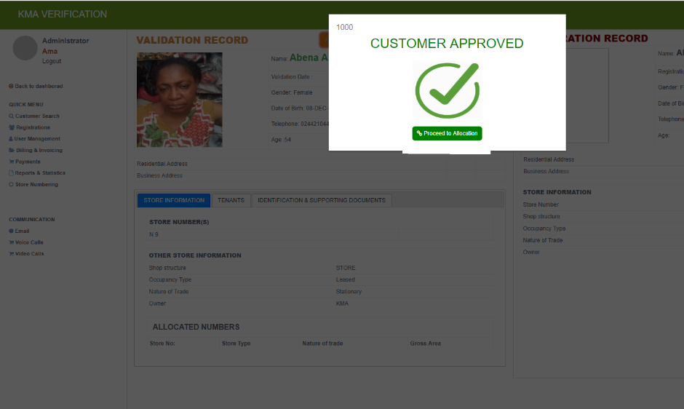Select a section before picking the store. The selected section (5) should correspond with the nature of trade (4).

1. Click on the allocate store (6) button on the resulting page.

Select the nature of trade and the store number in their respective fields (if a trader has more than one store in one nature of trade, the preferred stores can be selected all at once). Also select a billing cycle.

1. Click on preview invoice (7) to view invoice.
2. On the page that pops up, select process invoice (8) to view invoice options.

Select either print invoice (9) to print or complete process (10) to finish allocation.

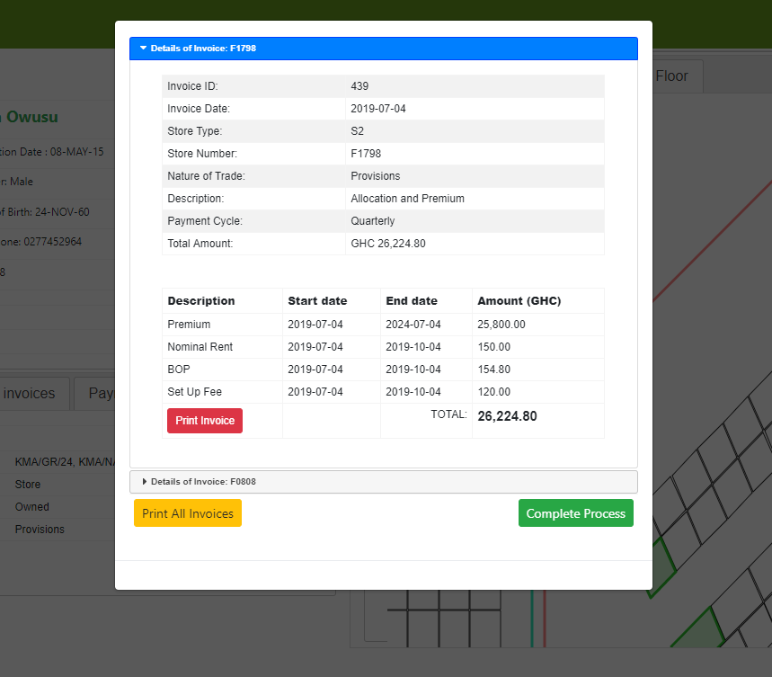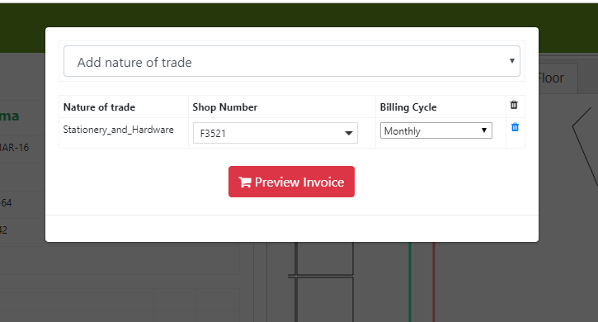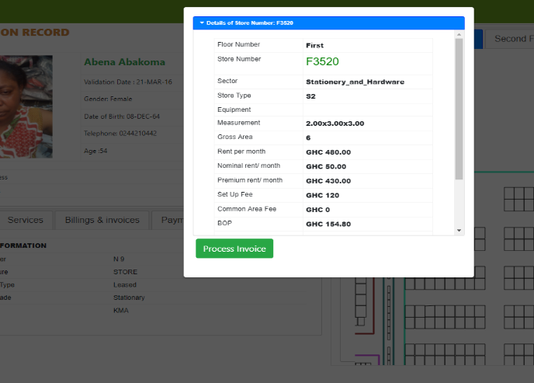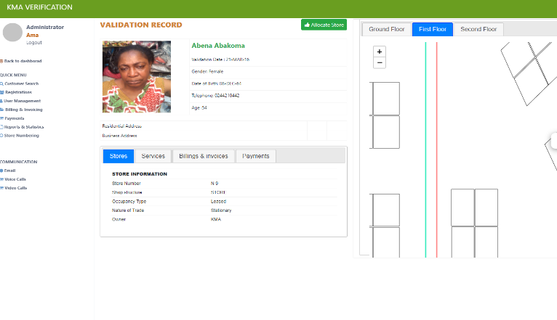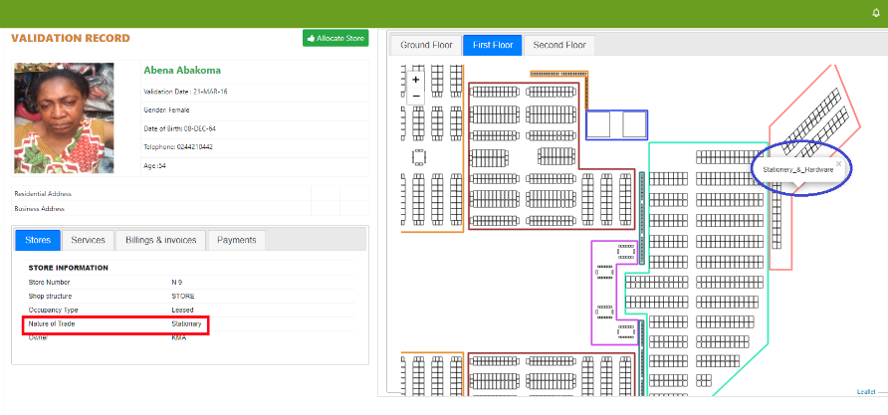

## **Change store Allocation**

In a case where the wants to change the store he or she chose, follow the instructions below:

1. 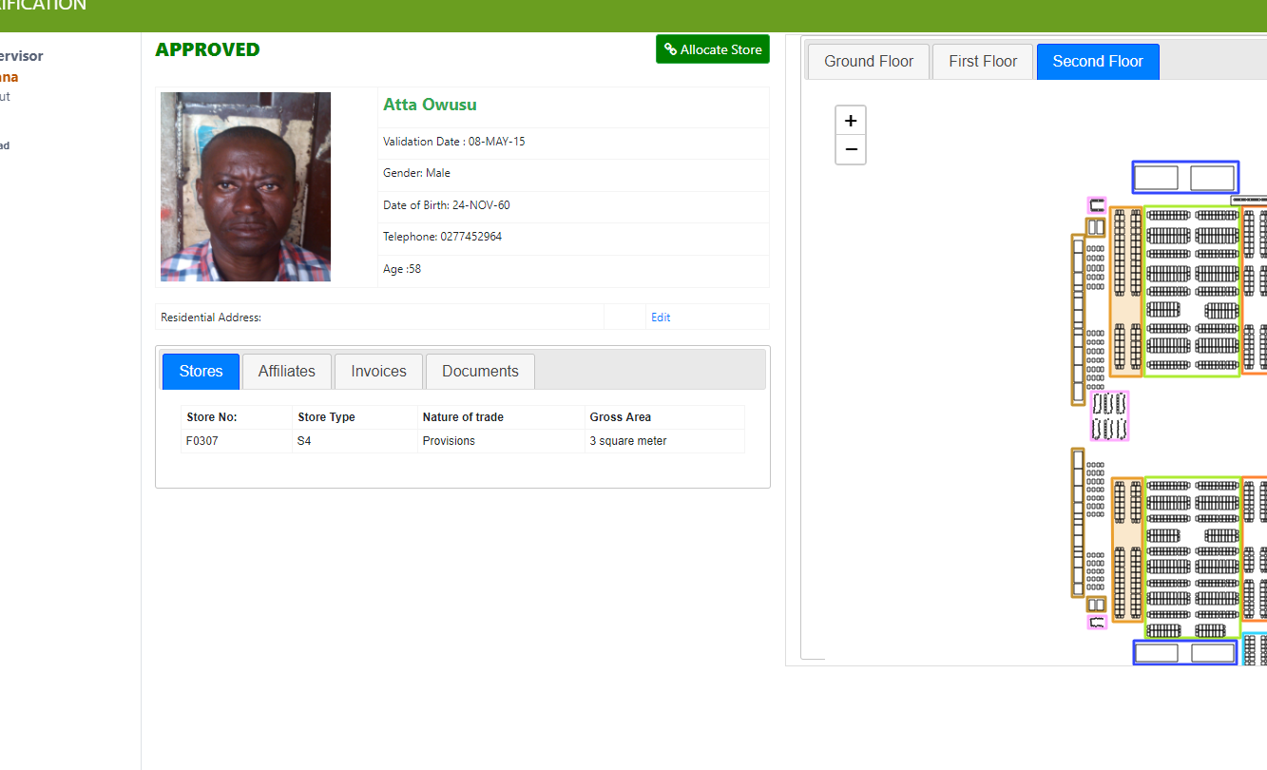On the approved page, click the store number under the stores tab (1).
2. Click the arrow in the select new store box on the pop-up screen and select trader’s preferred store number. (2)
3. Click submit to complete change. (3)

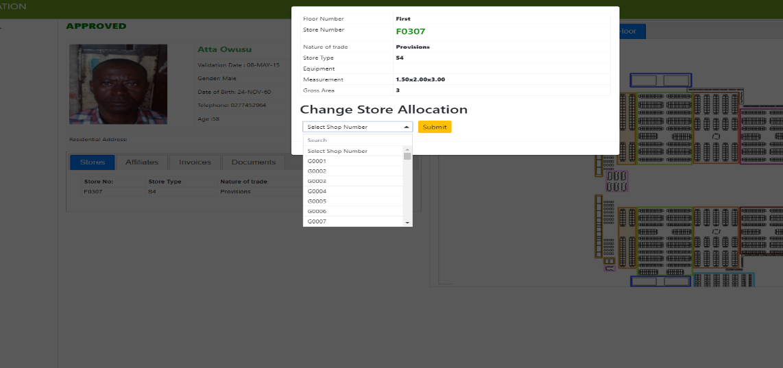

## 

## **Multiple Allocation**

For a trader who has already been approved but may have more than a shop in different nature of trades, repeat step 1 to step 7.

Notice that button (2) has changed to a proceed to allocation button since the trader has already been approved. For that particular step (***i.e. step 2***), click on the proceed to allocation and continue as required.

## **Adding Affiliates**

This allows you to add co-owners and tenants to a particular trader’s profile. Remember this can be done for **ONLY** approved traders.

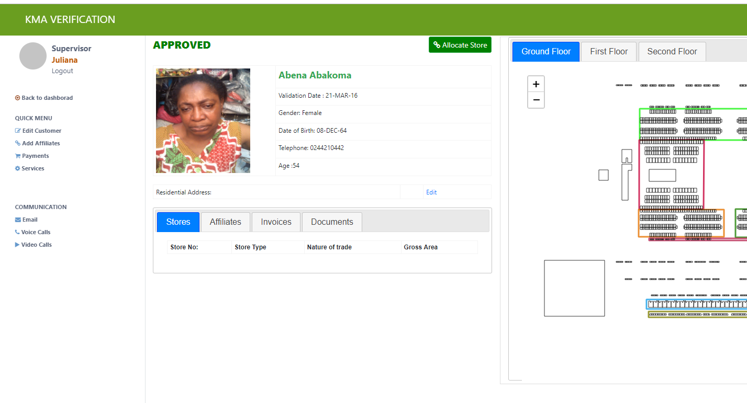

1. In the quick menu on the approved page, click on add affiliate (1).
2. On the screen that comes up, type in the number of the co-owner or tenant and click the search (2) button.
3. Select the type (3) of affiliate the person is (*i.e. co-owner or tenant)* and click on add (4).
4. Click OK (5) on the notification screen that comes up to finish adding an individual.

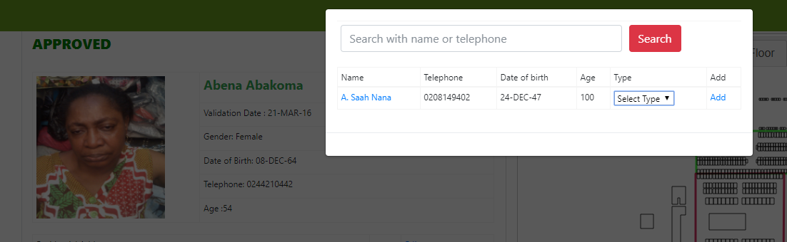

1. View an individual’s affiliates (6) by clicking on the affiliates tab.

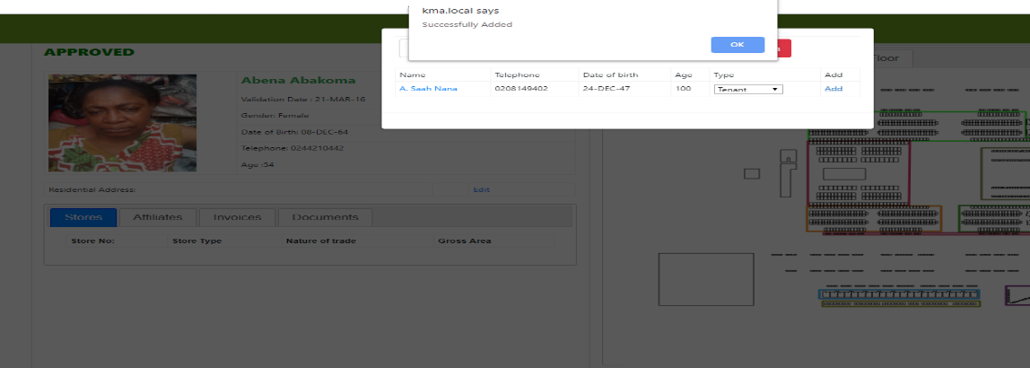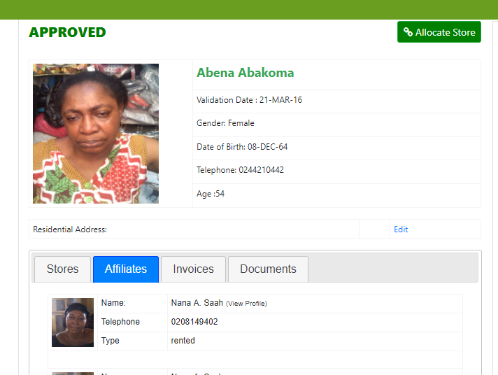

## **Changing allocated store**

This allows changes in store numbers and trades assigned to a trader. The following steps is used when a mistake arises during allocation.

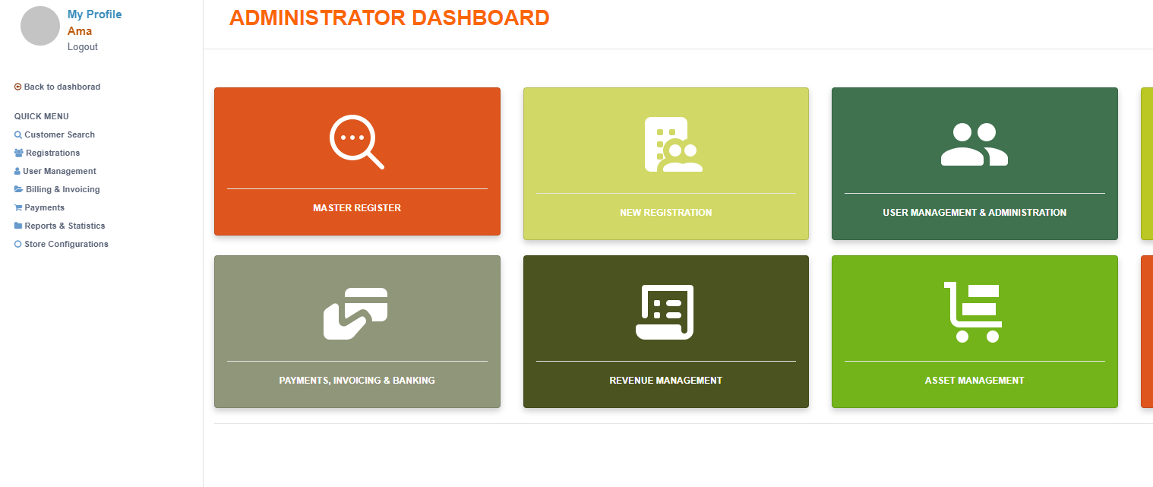

1. From the administrator dashboard select master register (1).
2. Click the allocated stores widget to access the allocated stores list (2).
3. On the page that results, type in the name or the number of the trader the changes need to be made to in the search box. Press Enter to access.
4. 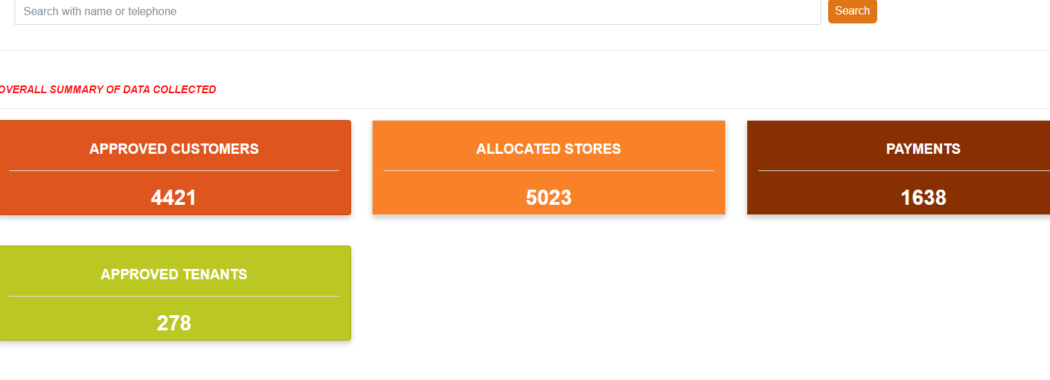 Click on the name of the customer in the table displayed.
5. On the approved page, click on the store number to begin changes.
6. On the pop-up screen, click the select shop box and select a new store number.

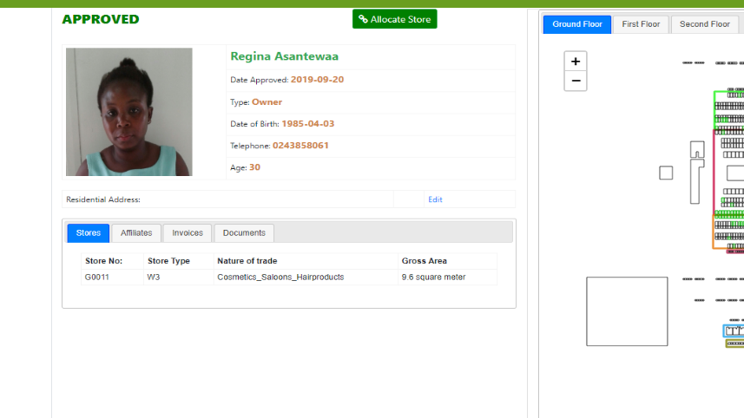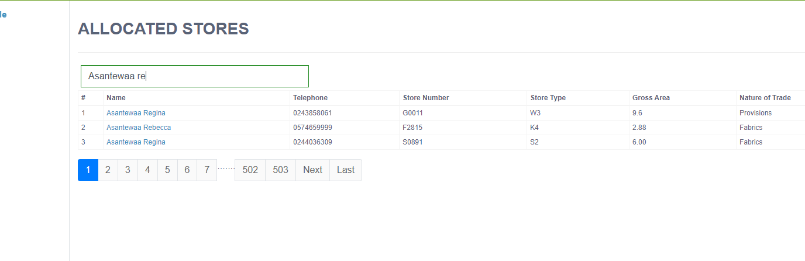

# **CHAPTER FIVE**

# **ASSET MANAGEMENT**

This chapter discusses assets allocation, configuration, listing, accounting and maintenance.

All assets paid for during the project should be imported and an asset manager set up for it.

On the dashboard click on the asset management widget to access the asset management dashboard.

## **Asset Manager Dashboard**

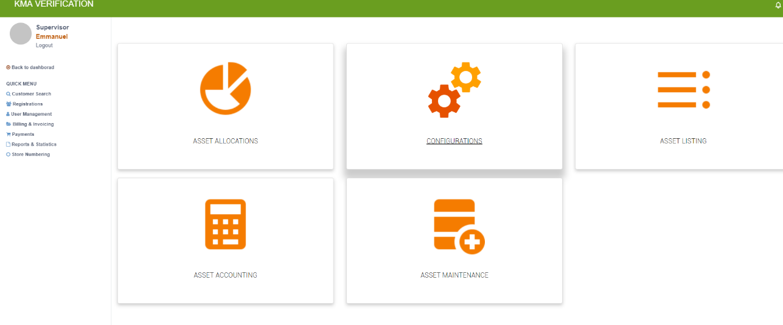

***Asset Manager Dashboard***

### **Asset Allocation**

Asset allocation allows distribution of assets/properties to entities for easy tracking and safe record keeping. Follow the steps enumerated below to allocate an asset

1. 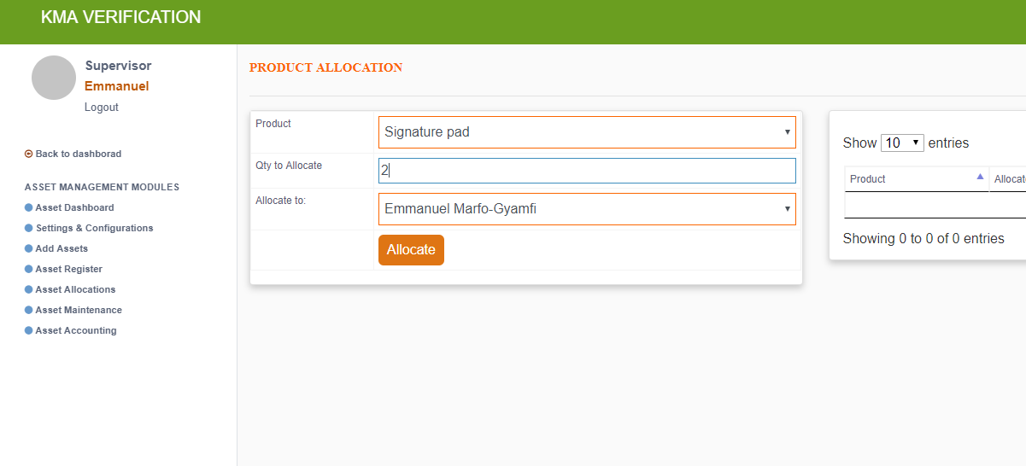On the dashboard click on asset management (1) on the dashboard
2. On the product allocation page select the product to be allocated (1), type in the quantity (2) and then select the person the allocation (3) is being made to.
3. Click on the allocate (4) button to complete the asset allocation.

### **Setting and Configuration**

This widget allows for an asset category to be added and changes to be made to be made. Click widget (2) to access it.

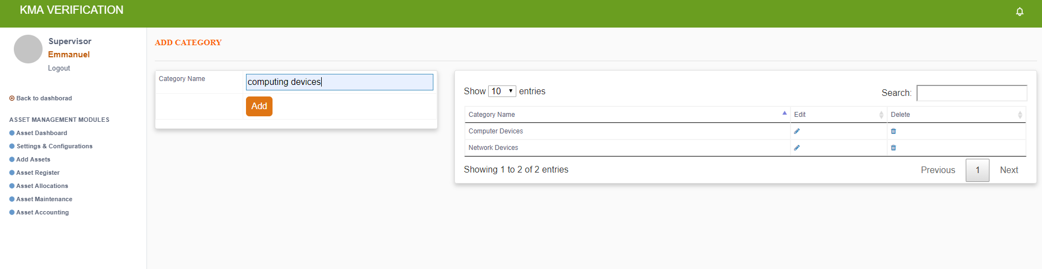

1. Add a new category by typing in the category name and clicking on the add (1) button.

***The added category will be immediately displayed on the table.***

1. Use the search button to find a particular category name in the table
2. In the table click on  to delete an unwanted category or  to edited a particular category.

### **Add Asset/Property**

Add an asset information, costing, depreciation and maintenance. Fill out each tab by adding the required information.

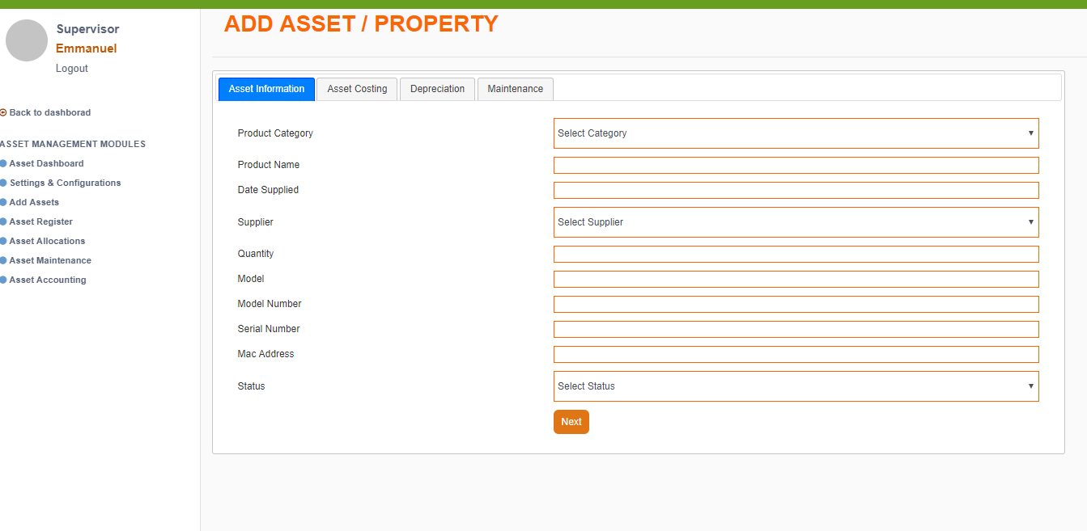Click on add asset on the asset management modules (1) to add a property/asset.

1. Fill out the asset information on (2), asset costing (3), depreciation (4) and maintenance plan (5).
2. On the maintenance tab click (6) tab to complete asset addition

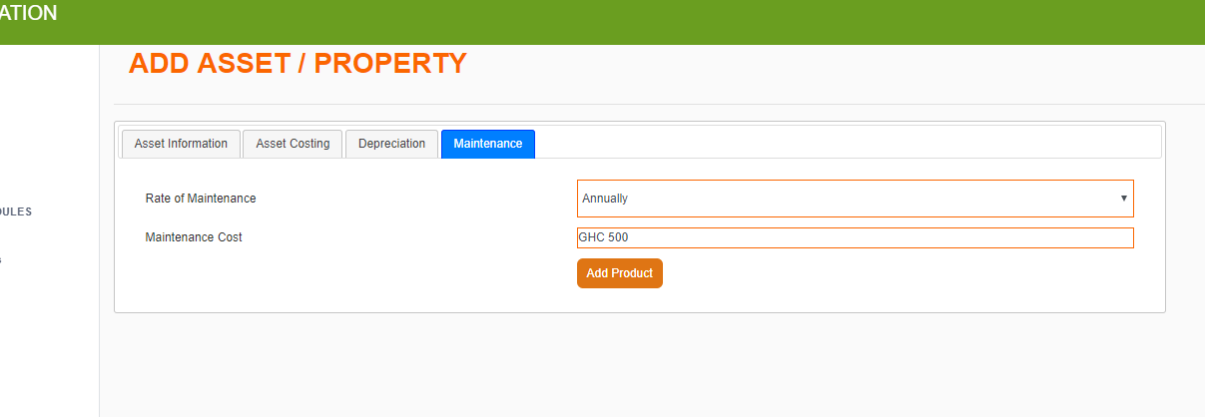

### **Asset Listing/Registration**

The asset list/register is accessible as asset register in the asset management modules list and as asset register on the asset management dashboard.

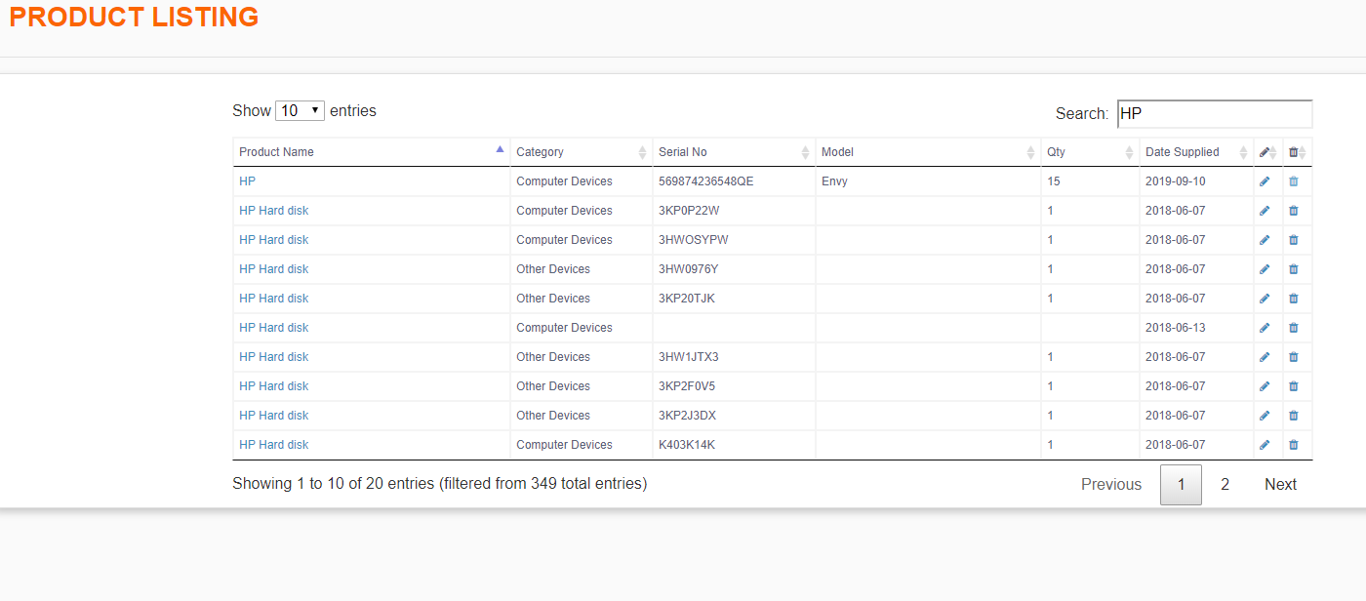

The register has all the enlisted assets items. From here, an item’s information can be deleted by clicking on  or edited by clicking on  .

In the search box (7), type in the item name for easy access.